Career Identity
  - working
Chungil Chae
Thu, 5 March 2026
Table of contents

Project Details
Updated in 2021-09-01

Citation

Abstract
This integrative literature review synthesizes findings from 713 peer-reviewed papers (2000-2025) examining multiple occupational identities and career development across diverse professional domains. Drawing upon a multi-layered conceptual framework integrating developmental, constructionist, multiplicity, and contextual theories, this review organizes findings around four major themes: (1) identity formation processes and mechanisms, (2) multiple identity integration, (3) career transitions and identity work, and (4) contextual factors shaping identity development. The analysis reveals professional identity formation (PIF) theory as the dominant framework (19.9% of studies), with qualitative methods predominating (52.6%). Key findings indicate that identity formation progresses through experiential learning, mentorship, and reflective practice, mediated by agency, self-awareness, and belonging. Multiple identity integration requires deliberate identity work supported by organizational structures. Career transitions represent critical junctures for identity reconstruction. The review identifies significant gaps in longitudinal research, quantitative measurement, cultural diversity, and intersectional analysis. Practical implications for educators, organizations, and individuals are discussed, alongside a comprehensive research agenda for advancing the field.
Keywords: professional identity formation, occupational identity, career development, identity work, multiple identities, systematic review

Planning

Schedule
- w0: 현재 자료들 리뷰 및 방향성 고민 () / 유관주제 Definiiton 정리 및 분석(유사, 상의) multiple career identity, multiple occupational identity, plural occupational identities, portfolio career, multiple persona
- w1: 13일 미팅반영해서 프로포절 작성 및 RAG 및 서칭 크리에티아, Biblio (Jan 18)
- w2: 리뷰 및 노트작성(Feb 1) / 키 아티클 선정 및 리뷰 계획/ Searching strategy, inclusion/exclusion
- w3: 리뷰 및 노트작성(Feb 8) / 기본분석 (bibliometrics report, RAG output, topic modeling)
- w4: 드레프트 작성 (Feb 15)

Progress
- Project kick off (jan 13, 2026)
- Progress 2

Authorship and Authors

Author Contribution
- Supervision: Chungil (Chad) Chae
- Project administration:
  - Chungil (Chad) Chae
- Conceptualization:
  - Chungil (Chad) Chae
- Data accusation:
- Data curation:
- Formal analysis:
- Chungil (Chad) Chae
- Investigation:
- Methodology:
  - Chungil (Chad) Chae
- Resources:
- Validation:
- Visualization:
- Writing – original draft:
  - Chungil (Chad) Chae
- Writing – review & editing:
  - Chungil (Chad) Chae

Authors

Chungil Chae, Ph.D., M.S.
- chadchae@gmail.com
- orcid: 000-0002-7364-1525
- Google Scholar
- Chae (2024)
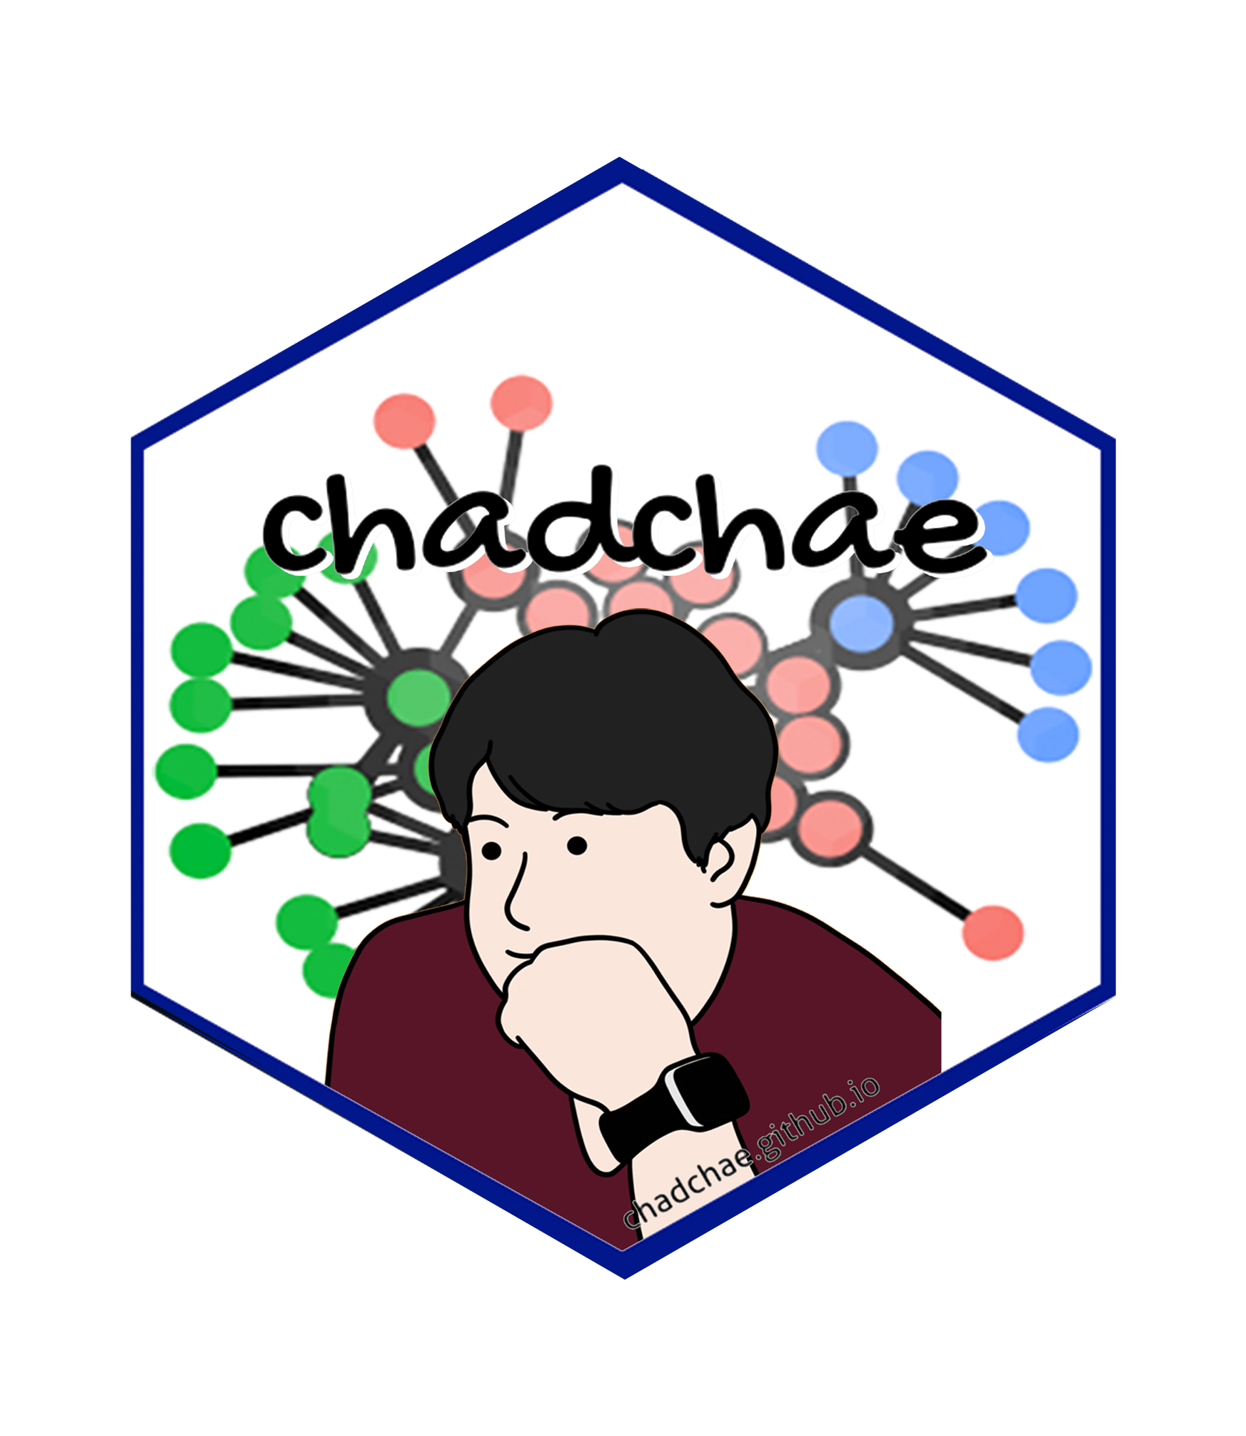
Chungil Chae Chae (2024) is an assistant professor in the field of business analytics, with a distinguished track record in organizational behavior, human resource development (HRD), learning, and development. With a prolific publication record that spans various dimensions of HRD and organizational studies, Dr. Chae has made significant contributions to understanding the dynamics of organizational support on knowledge sharing, virtual team leadership, and the structural determinants of HRD research collaboration networks. And his work embodies a deep commitment to enhancing understanding and practices in organizational behavior, HRD, learning, and development. His interdisciplinary research not only contributes to academic discourse but also offers tangible strategies for organizational improvement and individual development.

Author Bio 1
- tba
image or logo
bio here

Acknowledgement
- tba

Declearation

IRB

Funding

AI

Research Log

xxxx-xx-xx
- entry.

Meeting Log

xxxx-xx-xx
- 10:00-10:30: Kick-off meeting

Analysis Version

Version 0.0.1
- Starting draft

Draft Version

Ver 0.0.1
- Starting draft

Ideas and Thoughts

Research Q & A

Procedures

Related Theories

Theortical Relationship

Theoritical Framework

Hypothesis

Methdology

Method

Data Collection

Data

Searching and Inclusion & Exclusion

Round 1

Search kewwords and category

keywords combination

Round 2

Search kewwords and category

keywords combination

Round 3

Search kewwords and category

keywords combination

PRISMA

Reference List
Category, Classification and Decision Note for Selected Literature in Rounds

Round 1

Round 2

Round 3

Additional (during and after writing)

Reserach Problems

Key References

Quotes and Paraphrases

Products

References
Chae, C. (2024). Introduction to chad (chungil) chae. https://chadchae.github.io

