Extending Communities of Practice Through Digital Networks: A Relational Event Model Analysis of Knowledge Sharing Dynamics in an Online Professional Community
  - working
Chungil Chae
Thu, 5 March 2026
Table of contents

Project Details
Updated in 2025-11-24

Citation

Abstract
In today’s hyper-connected environment, organizations increasingly rely on distributed expertise and cross-boundary knowledge exchange to remain competitive. While Communities of Practice (CoPs) have been widely recognized as essential structures for collective learning, the rise of digital technologies has enabled a new form of community—extended Communities of Practice (eCoPs)—that transcend geographical, organizational, and temporal boundaries. These digitally mediated, fluid networks connect diverse practitioners and support continuous, practice-oriented knowledge sharing. Despite their growing importance, theoretical and methodological tools for understanding the temporal dynamics of knowledge exchange in eCoPs remain limited. Existing research often relies on static or aggregated network representations that obscure the sequential, event-based structure of knowledge interactions. To address this gap, we apply Relational Event Models (REM), a statistical framework designed to analyze time-stamped interaction sequences and capture how prior events shape subsequent behavior. Using four months of interaction data from CloudBro, an online professional community of IT practitioners, we examine 216 relational events generated by 59 participants across 309 posts in 89 discussion threads. By leveraging REM’s temporal granularity, this study elucidates how conversational sequences, reciprocity, and emergent attention patterns structure knowledge flows in an extended CoP. The findings contribute to theory development on digital knowledge communities and offer practical insights for designing and managing effective eCoPs.

Planning

Schedule
- Nov, 2025
  - Draft
- Dec, 2025
  - Submit

Progress
- Pilot analysis done
- writing

Authorship and Authors

Author Contribution
- Supervision: Chungil (Chad) Chae
- Project administration:
  - Chungil (Chad) Chae
- Conceptualization:
  - Chungil (Chad) Chae
- Data accusation:
- Cloud Bro
- Data curation:
- Jiongcheng Lu (Tony)
- Formal analysis:
- Chungil (Chad) Chae
- Jiongcheng Lu (Tony)
- Investigation:
  - Jiongcheng Lu (Tony)
- Methodology:
  - Chungil (Chad) Chae
  - Jiongcheng Lu (Tony)
- Resources:
- Validation:
- Visualization:
  - Jiongcheng Lu (Tony)
- Writing – original draft:
  - Chungil (Chad) Chae
  - Jiongcheng Lu (Tony)
- Writing – review & editing:
  - Chungil (Chad) Chae

Authors

Chungil Chae, Ph.D., M.S.
- chadchae@gmail.com
- orcid: 000-0002-7364-1525
- Google Scholar
- Chae (2024)
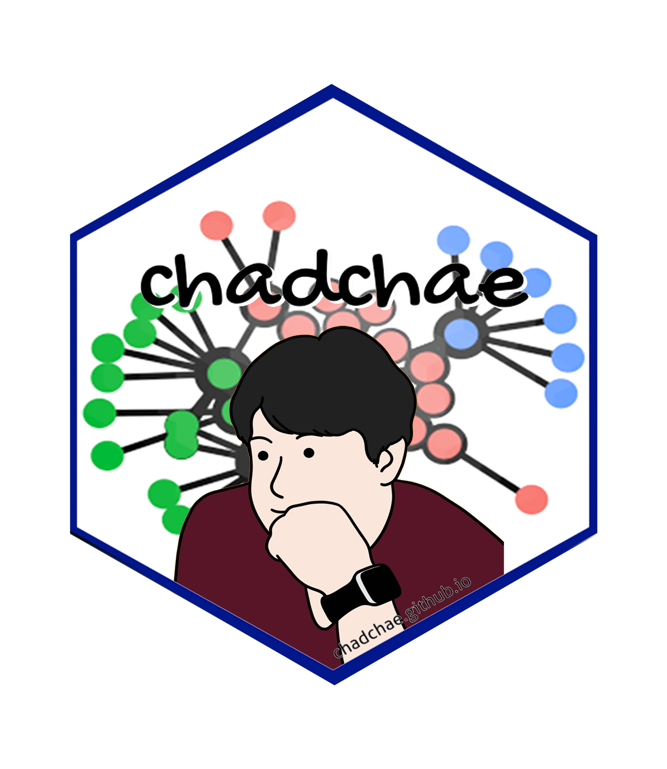
Chungil Chae (Chad) is an assistant professor in the field of business analytics, with a distinguished track record in organizational behavior, human resource development (HRD), learning, and development. With a prolific publication record that spans various dimensions of HRD and organizational studies, Dr. Chae has made significant contributions to understanding the dynamics of organizational support on knowledge sharing, virtual team leadership, and the structural determinants of HRD research collaboration networks. And his work embodies a deep commitment to enhancing understanding and practices in organizational behavior, HRD, learning, and development. His interdisciplinary research not only contributes to academic discourse but also offers tangible strategies for organizational improvement and individual development.

Jiongcheng Lu (Tony)
- lujiongcheng1@gmail.com
- orcid:
- google scholar:
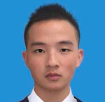
JJiongcheng Lu (Tony) is a Ph.D candidate. He hold a solid interdisciplinary background that bridges industry experience with academic research. He completed undergraduate studies at Wenzhou-Kean University, a Sino–American joint institution, majoring in Finance and minoring in Economics. During his studies, he served as a Teaching Assistant for Python and R data analysis and programming, and worked as a Research Assistant on projects involving data mining and healthcare accessibility in collaboration with Kean University. He later completed master’s degree at University College London (UCL), where He focused on the intersection of finance and the healthcare sector. After graduation, he worked as a Research Assistant in Health Economics at Peking University, further strengthening his quantitative and analytical expertise. He is currently pursuing PhD at the University of Sydney. Beyond academia, He have completed internships at banks, investment institutions, and technology research institutes, gaining broad exposure to finance, innovation, and applied research. He also founded own technology startup, which provided hands-on entrepreneurial experience.

Seungsoo Uh
- email:
- orcid:
- google scholar:


David L. Passmore
- email: dlp@davidpassmore.net
- Distinguished Professor, Emeritus, retired from Penn State University.
- Research Fellow, Ohio River Valley Institute, since September 2024.
- orcid:
- google scholar:

Was a graduate faculty member at Penn State University for 41 years, and, in sum, an instructor/professor in higher education for 51 years before retiring from Penn State in September 2020. Was a member of the graduate faculty in Workforce Education and Development. Served as the committee chair and dissertation advisor for 82 PhD recipients in Workforce Education and Development, Adult Education, and Mineral Engineering and Management. Also was the advisor for 20 theses by students earning master’s degrees in Workforce Education and Development.

Acknowledgement
- Qingtai Xu
  - xuqingtaieren@gmail.com
  - 

Declearation

IRB

Funding

AI

Research Log

xxxx-xx-xx
- entry.

Meeting Log

xxxx-xx-xx
- 10:00-10:30: Kick-off meeting

Analysis Version

Version 0.0.1
- Starting draft

Draft Version

Ver 0.0.1
- Starting draft

Ideas and Thoughts

Research Q & A

Procedures

Related Theories

Theortical Relationship

Theoritical Framework

Hypothesis

Methdology

Method

Data Collection

Data

Searching and Inclusion & Exclusion

Round 1

Search kewwords and category

keywords combination

Round 2

Search kewwords and category

keywords combination

Round 3

Search kewwords and category

keywords combination

PRISMA

Reference List
Category, Classification and Decision Note for Selected Literature in Rounds

Round 1

Round 2

Round 3

Additional (during and after writing)

Reserach Problems

Key References

Quotes and Paraphrases

Products

References
Chae, C. (2024). Introduction to chad (chungil) chae. https://chadchae.github.io

