Woman Leadership 10 years: Topic modeling and Computational Grounded Theory Approach
  - Final analysis complated
Chungil Chae
Thu, 5 March 2026
Table of contents

Synthesis and Revisiting Korean Women Leaders’ Narrative: A Computational Analysis Using Structural Topic Modeling

Abstract
Over the past eight years, we have conducted eight qualitative studies on women leaders in South Korea (Korea) from the lens of work-life balance and career and leadership development, using semi-structured interviews. Given the women leaders’ 200 narratives, we felt a strong need to reanalyze the interview data to tackle the subjectivity issue in qualitative research using topic modeling that is a computational technique to mining a large volume of texts. The purpose of this study, therefore, was to reanalyze women leaders’ narratives and to examine the research themes identified through a computational analysis. As a result, we identified key research topics on Korean women leaders’ narratives, compared those with the research themes from the previous qualitative studies, and provide implications for HRD research and practice for the future.

Planning

Schedule
- In March, complate a draft
- In April, review and revision, then submit

Progress
- Analysis Done

Authorship and Authors

Author Contribution
- Supervision: Yoonjoo Cho
- Project administration: Yoonjoo Cho
- Conceptualization: Chungil (Chad) Chae
- Data accusation: Yoonjoo Cho
- Data curation: Chungil (Chad) Chae, Sumi Lee
- Formal analysis:
  - Chungil (Chad) Chae
- Investigation:
  - Yoonjoo Cho, Jieun You, Sumi Lee
- Methodology:
  - Chungil (Chad) Chae
- Resources: Yoonjoo Cho
- Validation: Yoonjoo Cho, Jieun You, Sumi Lee, Chungil Chae
- Visualization: Chungil Chae
- Writing – original draft: Chungil Chae, Yoonjoo Cho, Jieun You, Sumi Lee
- Writing – review & editing: Yoonjoo Cho, Jieun You, Sumi Lee, Chungil Chae

Authors

Yonjoo Cho
University of Texas at Tyler

Chungil Chae, Ph.D., M.S.
- chadchae@gmail.com
- orcid: 000-0002-7364-1525
- Google Scholar
- Chae (2024)
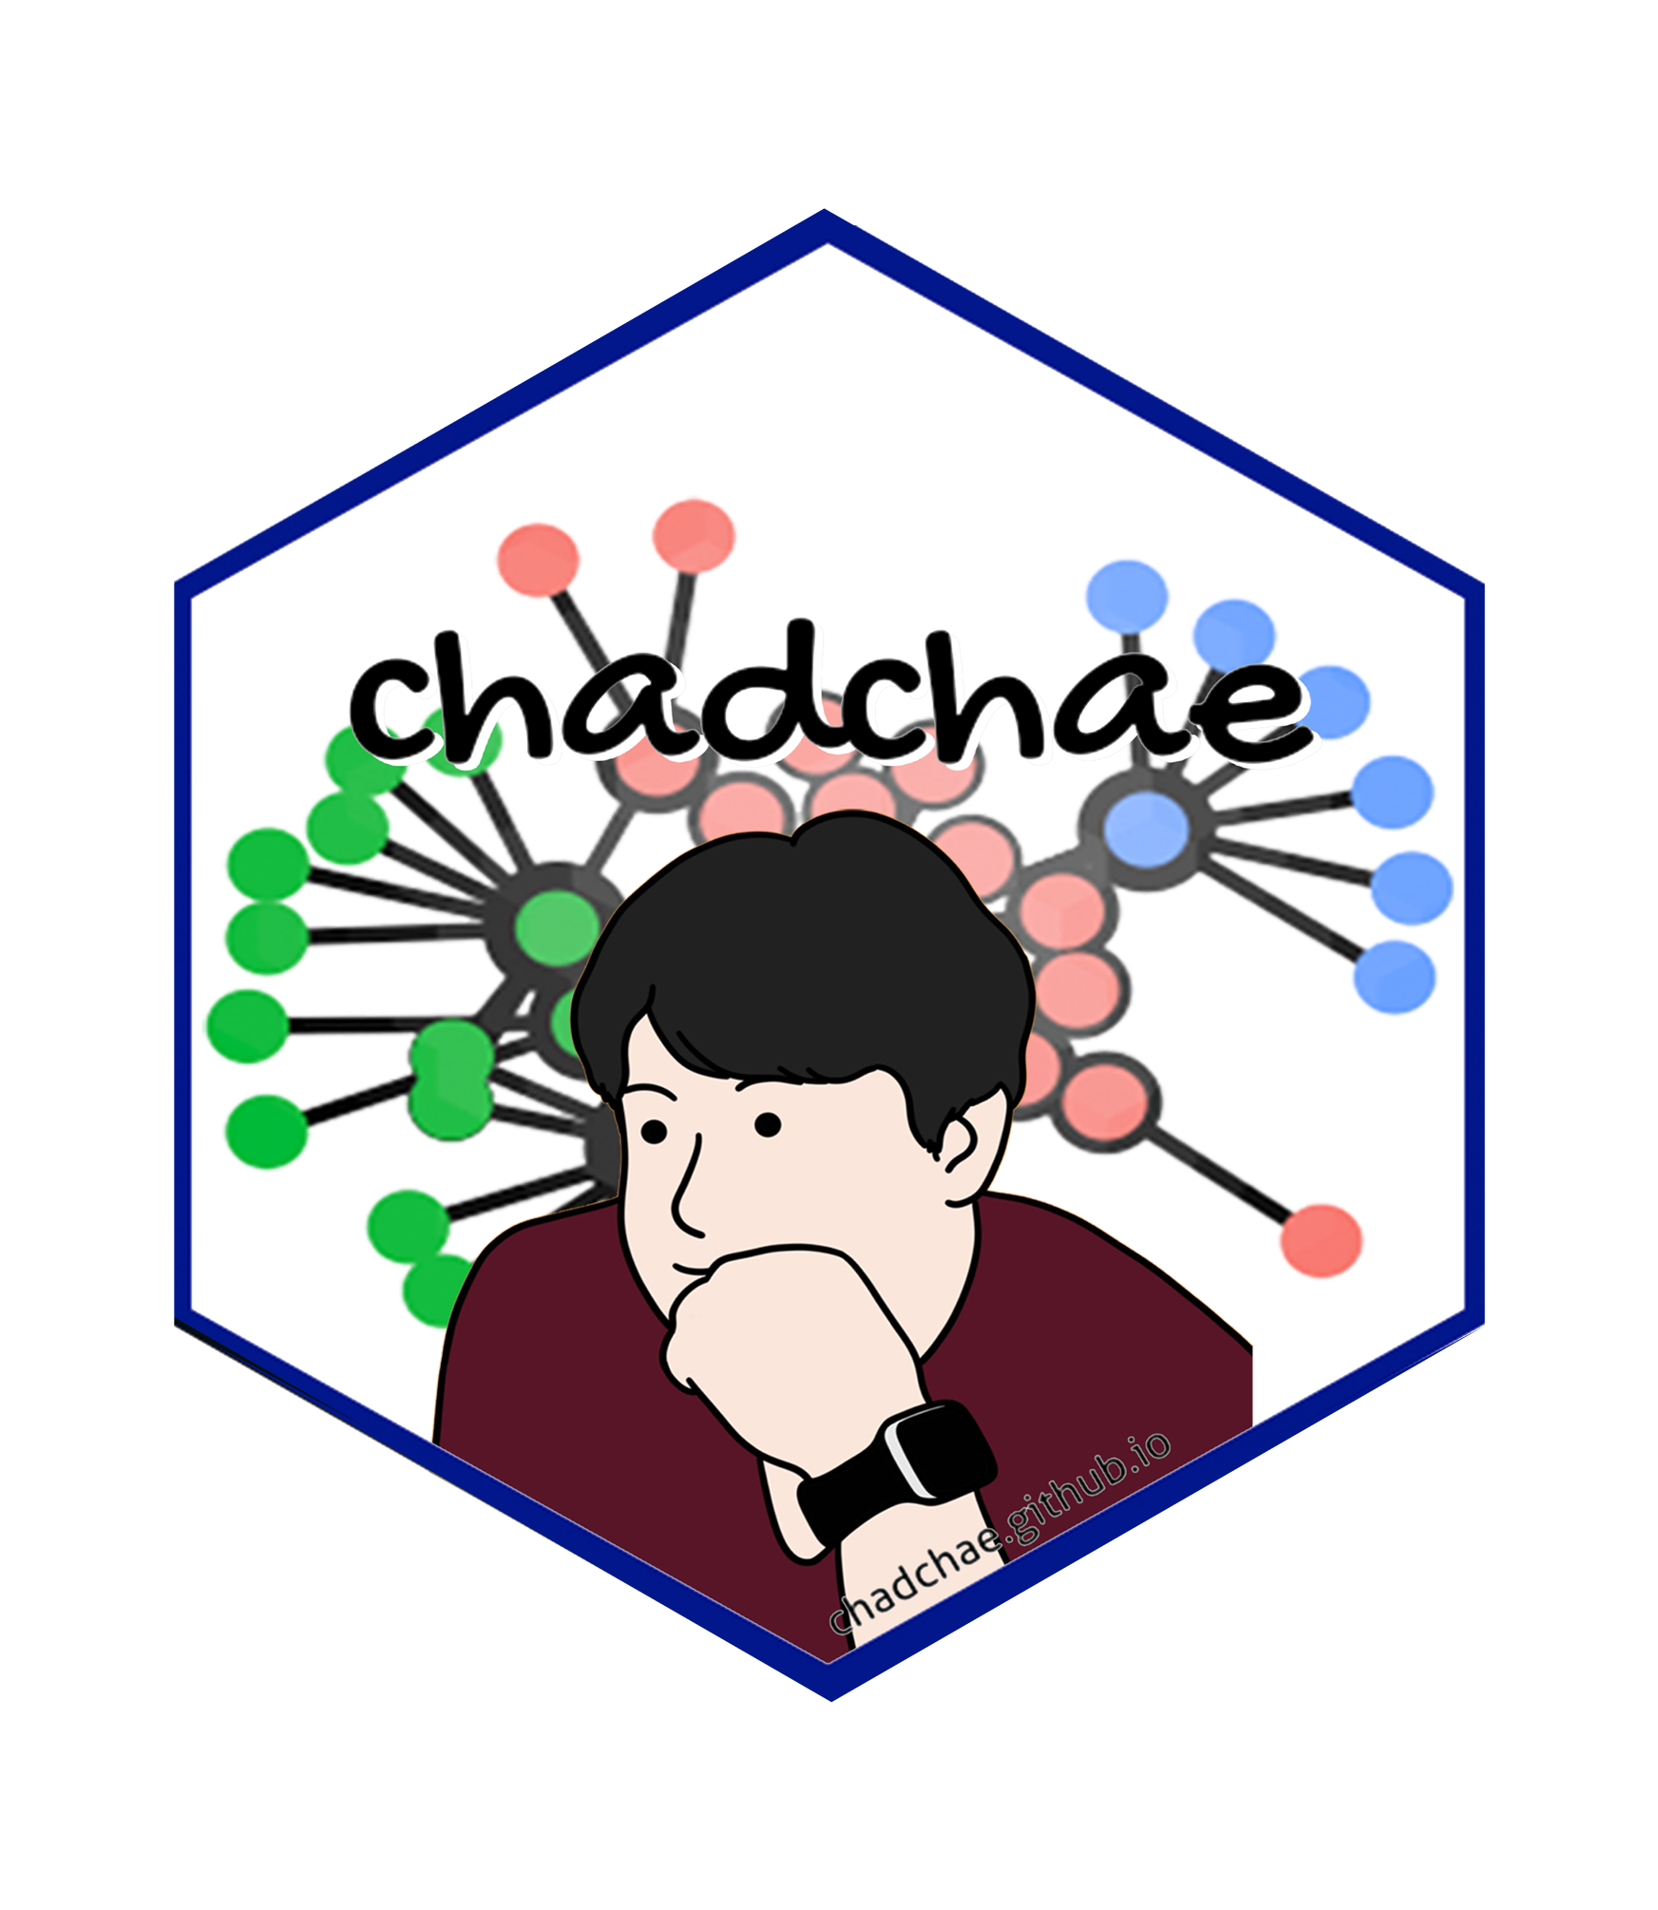
Chungil Chae (Chad), Ph.D., is an Assistant Professor in Business Analytics at Wenzhou-Kean University, specializing in data analytics, human resource development, and knowledge-sharing in multinational organizations. With a Ph.D. from Pennsylvania State University, his research integrates business intelligence, workforce education, and computational social science. Dr. Chae has an extensive publication record in top-tier journals and has received multiple academic awards, including the Outstanding Paper in the Emerald Literati Awards. He has held positions as a post-doctoral scholar at Penn State and has contributed to various funded research projects in cognitive science and business analytics. His expertise extends to teaching business analytics, data mining, and management courses while actively engaging in curriculum development and academic service.

Jieun You
Valdosta State University
- tba
image or logo
bio here

Sumi Lee
University of Georgia
- tba
image or logo
bio here

Acknowledgement
- tba

Declearation

IRB

Funding

AI

Research Log

xxxx-xx-xx
- entry.

Meeting Log

2024-03-29
- Discussion
  - Chad
    - Research home introducing (https://chadchae.github.io/rp_2024_woman_leadership/)
    - Currently working with 5 different models
    - Suggestion
      - Set a labeling with Dr.Yoo and Dr.Chae and then Dr.Cho and Dr.Lee check
  - Dr.Cho
    - updating contents on google drive (draft)
- Next meeting
  - April 13, 11:00 PM (China)

Analysis Version

Version 0.0.1
- Starting draft

Draft Version

Ver 0.0.1
- Starting draft

Ideas and Thoughts

Research Q & A

Procedures

Related Theories

Theortical Relationship

Theoritical Framework

Hypothesis

Methdology

Method

Data Collection

Data

Searching and Inclusion & Exclusion

Round 1

Search kewwords and category

keywords combination

Round 2

Search kewwords and category

keywords combination

Round 3

Search kewwords and category

keywords combination

PRISMA

Reference List
Category, Classification and Decision Note for Selected Literature in Rounds

Round 1

Round 2

Round 3

Additional (during and after writing)

Reserach Problems

Key References

Quotes and Paraphrases

Fri Jul 21 02:27:35 KST 2022

일반적인 질문 (생각나는 대로)
- What is : (definition)
  - human resource analytics
  - people analytics
  - workplace analytics
  - learning analytics
  - computational social science
  - marketing analytics
  - audit analysis
  - business Analytics
- What is the charteristics of analytics
- What is the simiarlirty of the analytics
- What is difference between analytics
- What is main frame(core/idea) of the analytics

HRD master class에서의 질문
- What do we mean by Data Analytics
  - how it is defined and how does our understanding of the term vary around the world?
- What’s the relationship between Data Analytics and the concepts of work and the workplace?
  - how has that relationship changed over the years?
- What’s the connection between Data Analytics and HRD?
  - How does research, theory and practice in one influence research, theory and practice in the other?
- If we look at the challenges facing HRD in organizations over the next few years, how does Data Analytics help HRD in understanding those challenges and working on them?
- What do we mean by Data Analytics
  - how is it defined and how does our understanding of the term vary around the world?
- What’s the relationship between Data Analytics and the concepts of work and the workplace?
  - how has that relationship changed over the years?
- What’s the connection between Data Analytics and HRD?
  - how does research, theory and practice in one influence research, theory and practice in the other?
- If we look at the challenges facing HRD in organizations over the next few years, how does Data Analytics help HRD in understanding those challenges and working on them?
- I’m wondering what happens if HRD takes a more data analytics approach to addressing organizational challenges
  - to pick on one for an example, if we consider how best to help employees to learn from each other especially with employees working remotely or in hybrid forms,
  - how can data analytics help HRD to address that challenge?
- Within organizations, what HRD questions could you see data analytics answering in the coming years that, in most organizations, currently go unanswered?
- Earlier in the episode, you mentioned leveraging data that already exists within organizations – for a typical organization, what existing data could HRD use and where does that data reside?
- What advice do you have for HRD professionals who want to learn how to do data analytics
  - how to learn the basics of data analysis and what tools to use?
- What advice do you have on how HRD professionals could tap into data experts working within organizations
  - what job titles might those people have, and are there any best practices around how to work with them?

TWS세션에서의 질문
- 먼저 HRA/PA란 무엇인지 더 명확하게 알고싶습니다
  - HRA/PA이란 무엇을 의미합니까?
  - HRD 분야 연구/ 실무 측면에서HRA/PA 에 대한 이해 및 활용이왜 중요할까요?
  - HRD 입장에서 조직의 어떤 문제들을 해결해 줄까요?
- 현재까지 학계와 현장에서는얼마나 활용되고 발전해 왔는지 궁금합니다.
  - 먼저 연구 측면에서는 현재까지 어떤 발전/변화가 있었나요?
  - HRD 분야에서는 연구가 이루어 지고 있나요?
- 또 실무에서 HRD가 현장의 문제를 해결하기 위해 더 많은 데이터 분석 접근 방식을 취하면 어떻게 될지 궁금합니다.
  - HRD 현장/실무에서는 어느 정도 도입 및 활용이 되고 있나요?
  - 현장에서의 HRA/PA 적용 사례(Best Practice)가 있을까요?
- 그렇다면 당장 HRD 실무자들이 HRA/PA 도입 및 활용을 위해 무엇을 할 수 있을지 궁급합니다.
  - HRD에서 당장 사용할 수 있는 기존 데이터는 무엇이 있고 어떻게 활용 가능한지?
  - 어떤 결과를 기대 할 수 있는지?
  - 조직 내 타부서 또는 외부 데이터 전문가를 활용할 수 있는 방법도 있을까요?
- 마지막으로 앞으로의 방향성 그리고 HRD 실무자에게 주는 조언에 대해 여쭙고 싶습니다.
  - HRA/PA에 대한 전망과 HRD에 주는 시사점은 무엇인지?
  - 앞으로 HRA/PA를도입 하고자 하는 HRD 전문가에게 해주고 싶은 조언

## 리터리쳐들에서 도출된 질문들

References
Chae, C. (2024). Introduction to chad (chungil) chae. https://chadchae.github.io

